AWS Spark Wine Quality Prediction Application

**pySpark AWS Wine Prediction App** Is an application that was developed with Python's pySpark interface and installed on the AWR EMR cluster.

The purpose of this project is to leverage publicly available data to train a machine learning model in parallel on EC2 instances, with the goal of predicting wine quality. In order to make deployments easier, the project also uses Docker to produce a container image for a trained machine learning model.

**Link to GitHub code** –

<https://github.com/vijayasindhudandeboina/AWS-Spark-wine-Quality>

**Link to docker container image** -

<https://hub.docker.com/repository/docker/vijaya430/wine-prediction-app/general>

**Source files**:

`wine_prediction.py` reads Training dataset from S3 and trains model in parallel on EMR spark cluster. Once model is trained, it can be run on provided test data provided via S3. This program stores trained model in S3 bucket (Public URL for bucket - S3://wine-data-12)

`wine_test_data_prediction.py` program loads trained model and executes that model on given test data file. This will then print F1 score as metrics for accuracy of the trained model.

`Docker file` creates docker image and run container for simplified deployment.

## Instruction to use:

**Phase 1: Pre-requisites**

Prepare the PEM file, credentials, and AWS account (same as last assignment).

**Phase 2: Copy data to S3**

We will copy all the datasets given and also the python scripts to s3 in our bucket

**Phase 3: Establish an EMR Cluster**

### 1. Create Spark cluster in AWS

Using the EMR console that AWS provides, users can establish spark clusters.

Kindly follow the instructions to build one using four EC2 instances (you can use more, depending on your load).

1. Use the "EC2-> Network & Security -> Key-pairs" navigation to create a key pair for the EMR cluster.

Utilize the format pem. The {name of key pair}>.pem file will be downloaded as a result. To perform an SSH to an EC2 instance, you will need to keep it secure.

2. Go to the console for Amazon EMR. Next, select Clusters -> Create Cluster from the menu.

3. Now complete the corresponding sections:

Proceed to the General Configuration -> Cluster Name -> Software Configuration -> EMR 5.33 menu and choose 'Spark: Spark 2.4.7 on Hadoop 2.10.1 YARN and Zeppelin 0.9.0'.

Hardware Configuration -> Set the number of instances to 4.

Pem key generated in the previous step under Security Access -> Provide.

The remaining settings can be left as-is.

4. Following a successful cluster creation, the cluster status should be "Waiting."

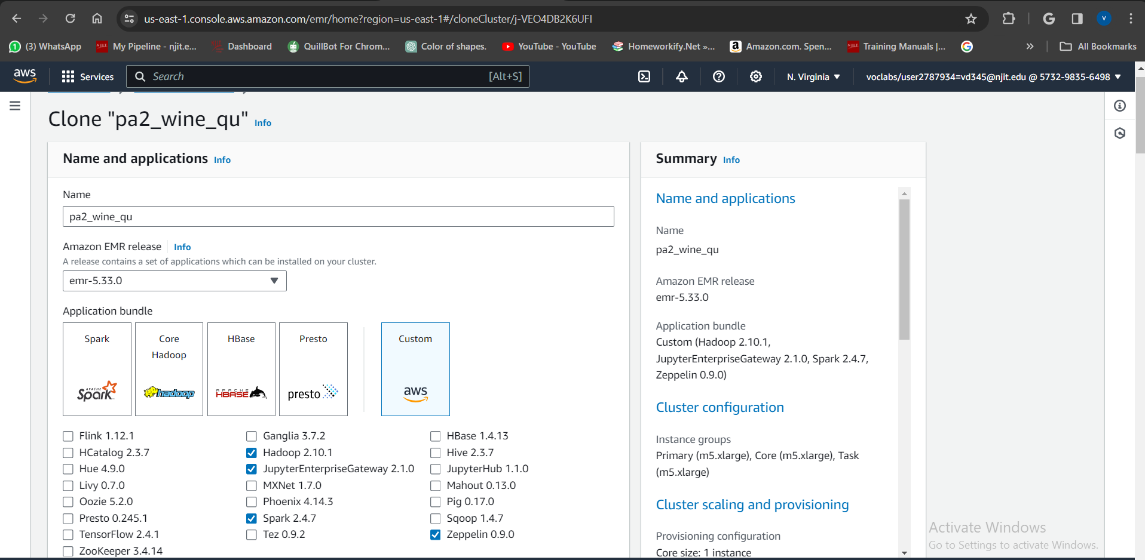

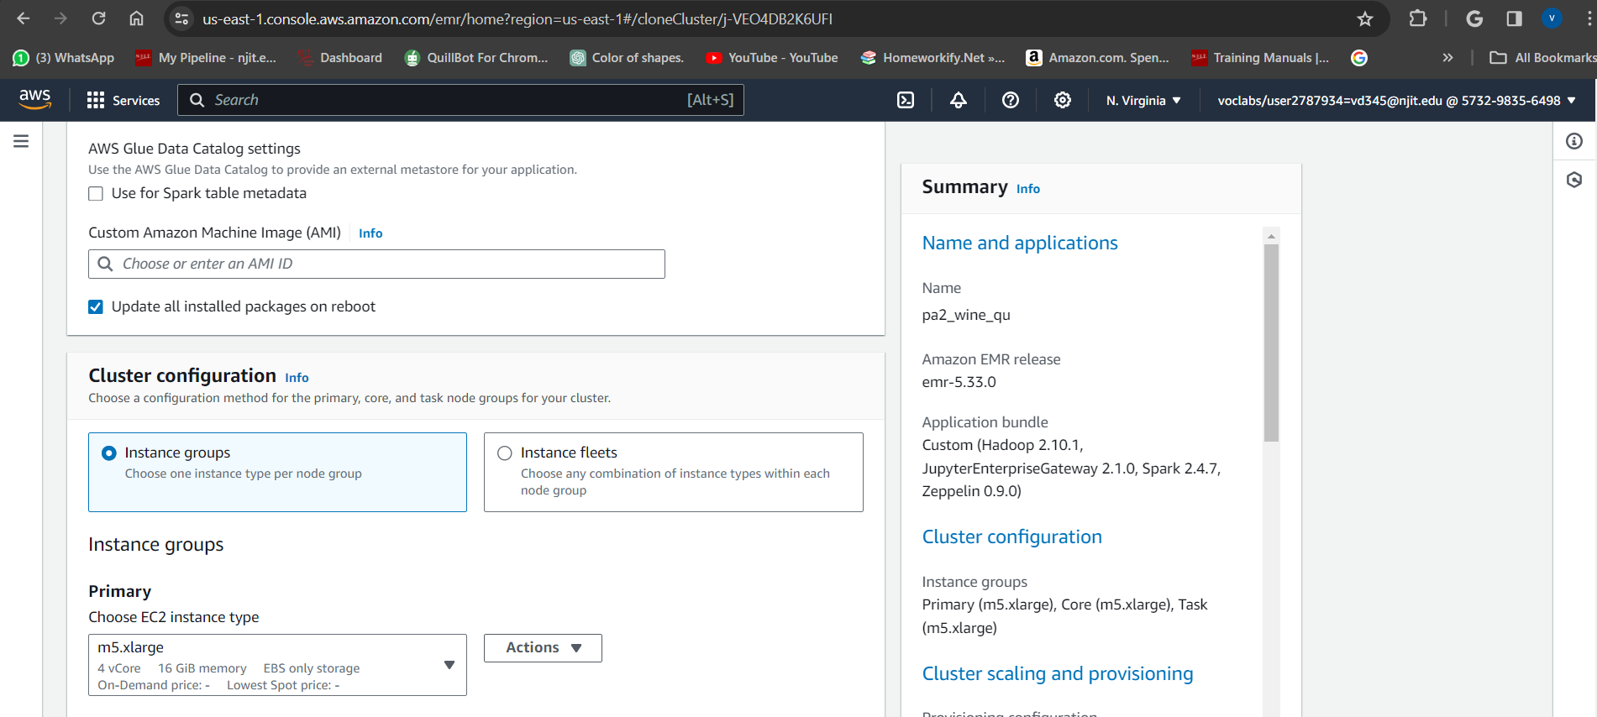

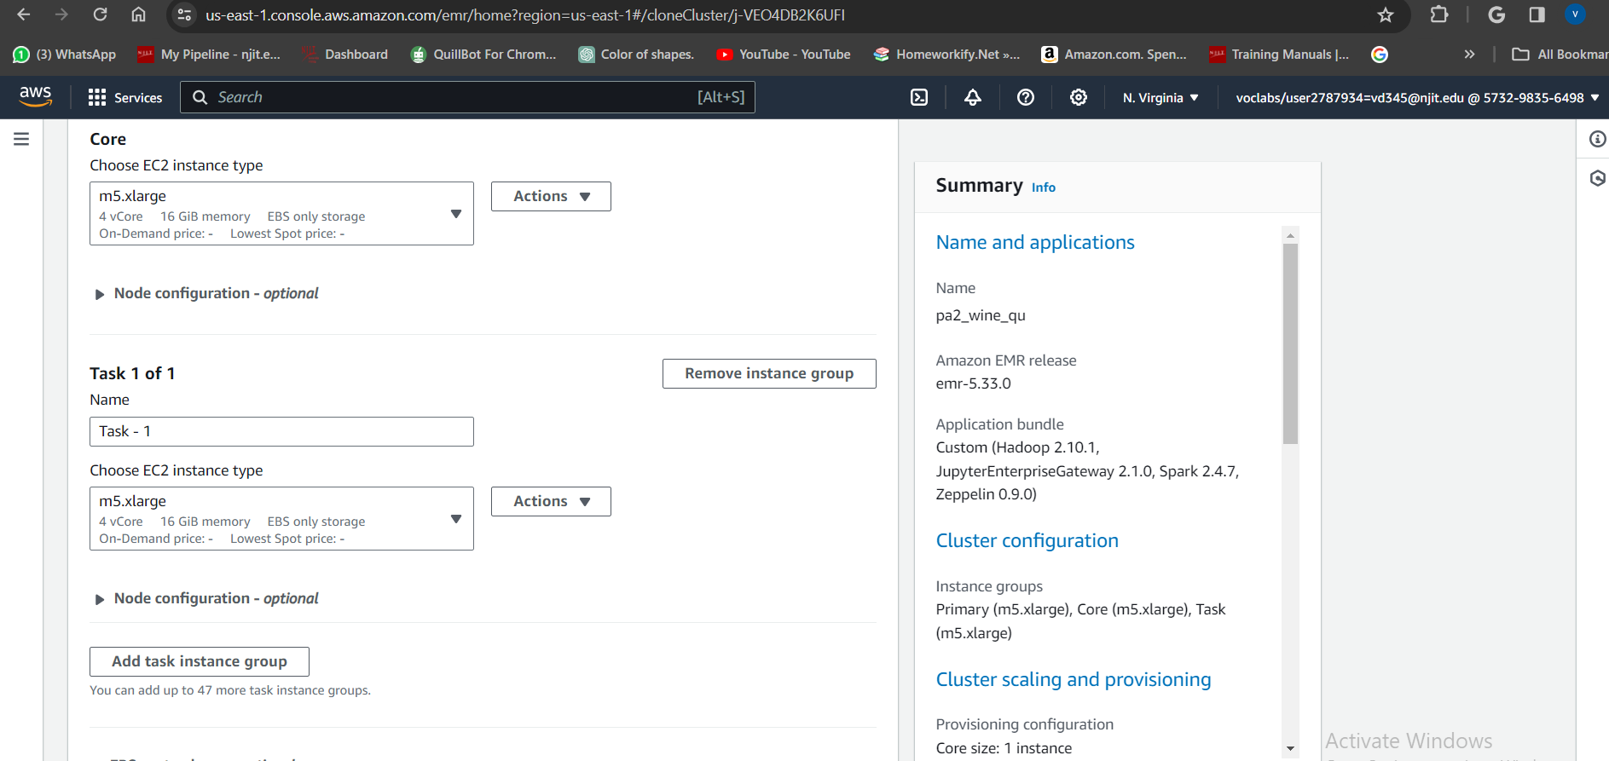

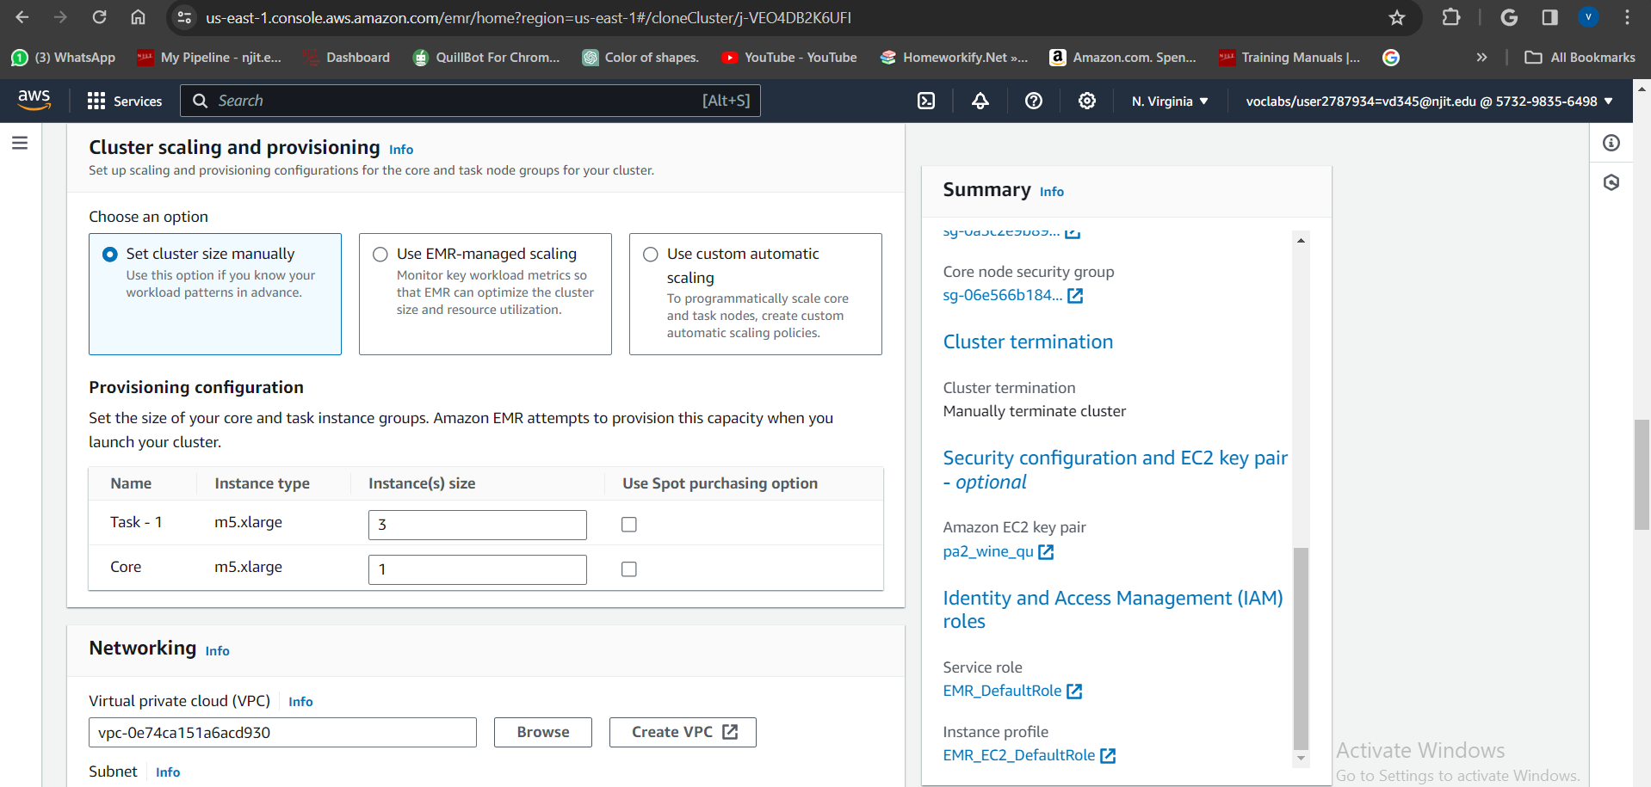

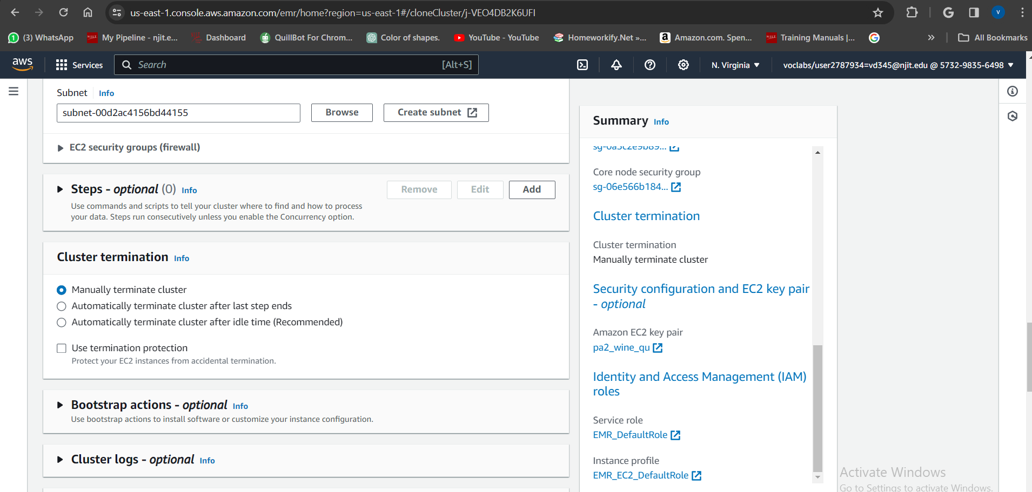

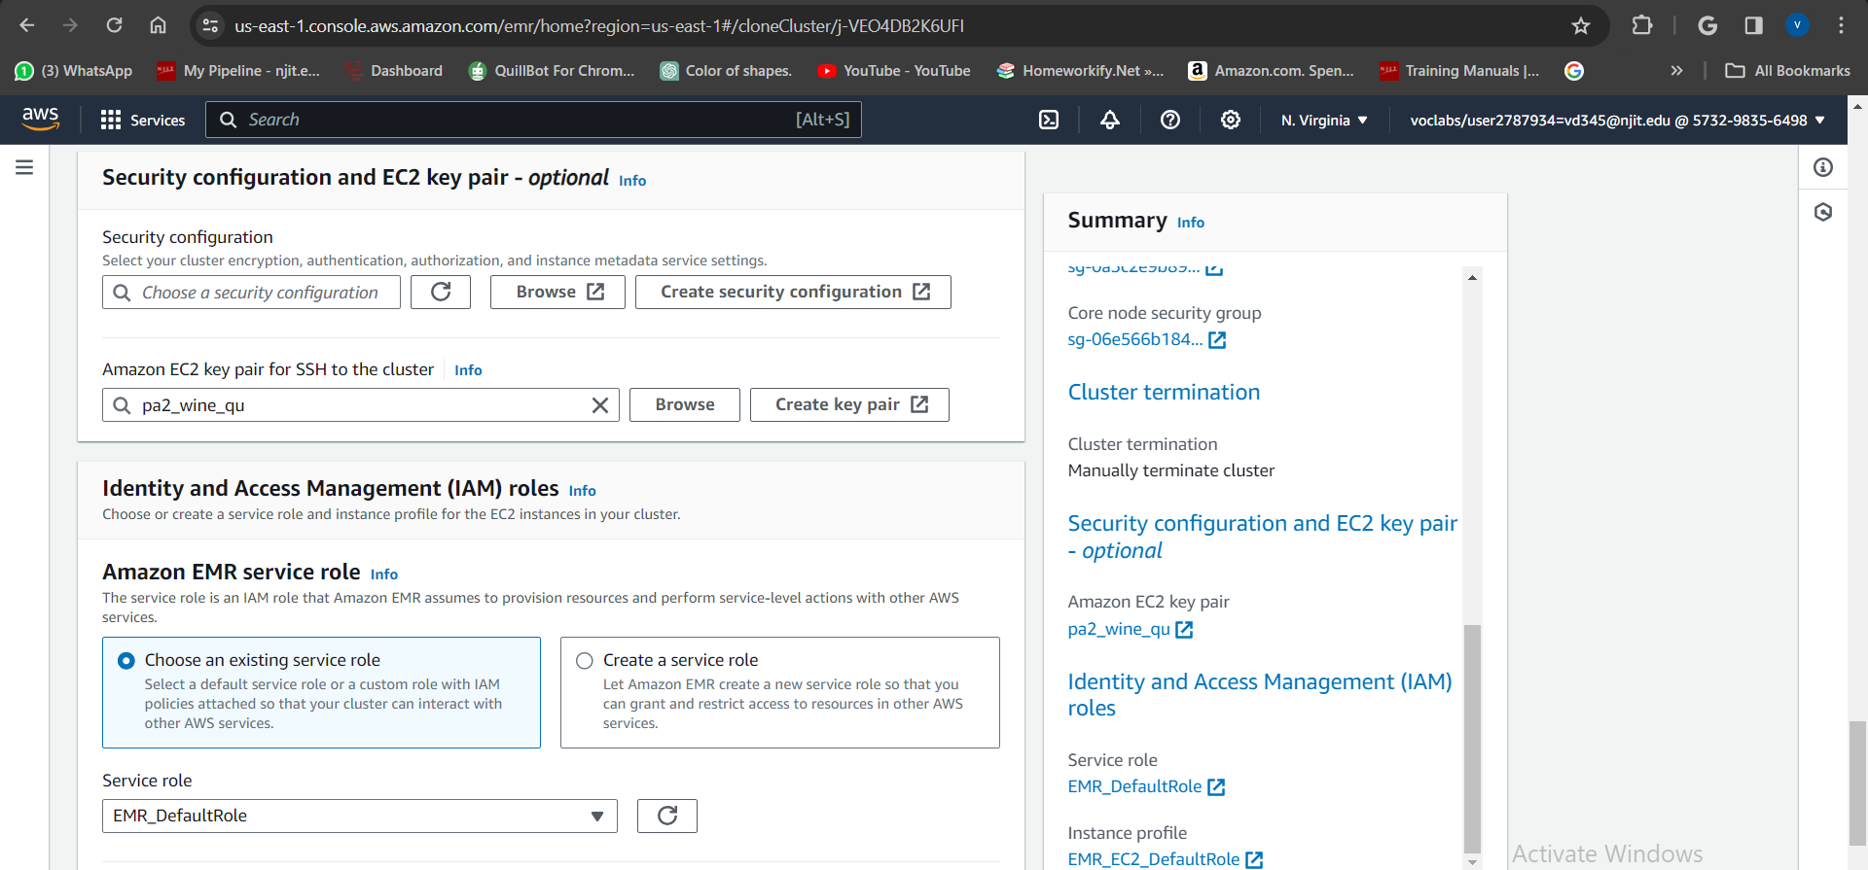

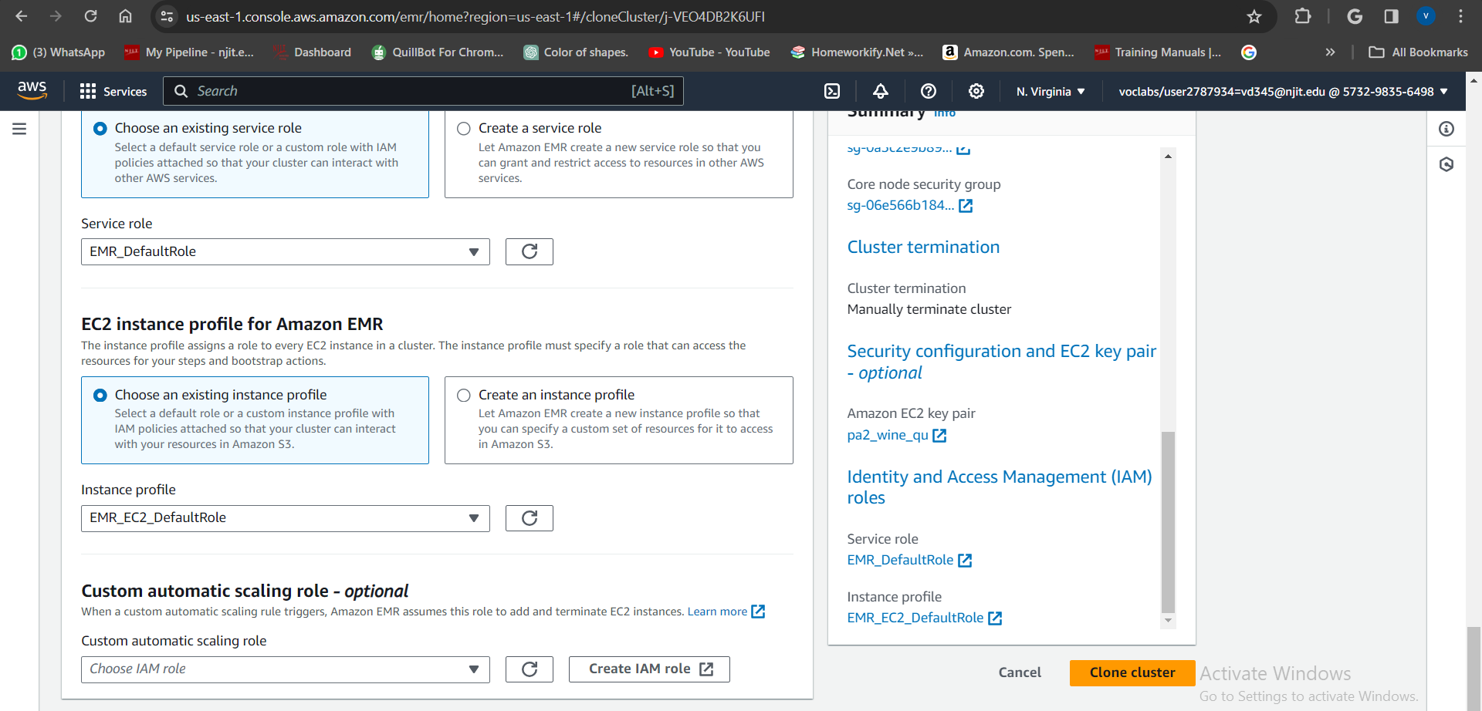

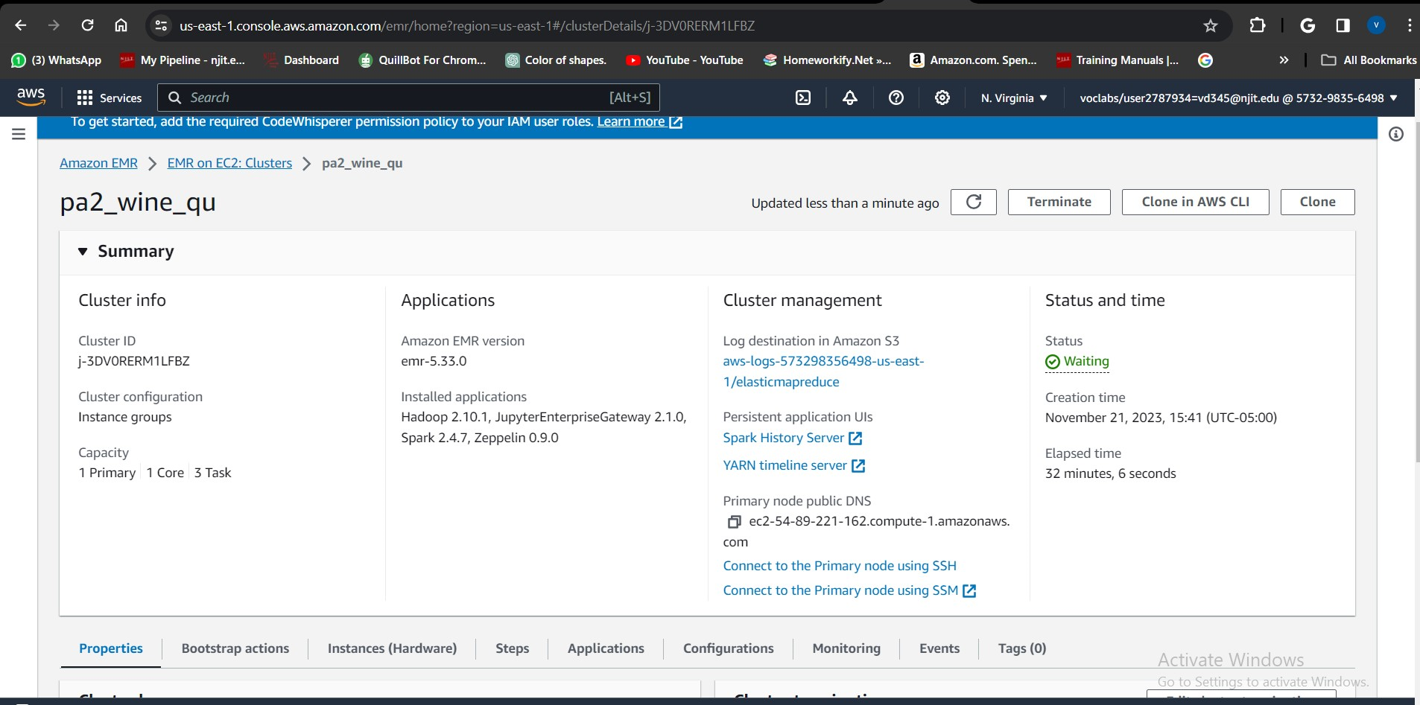

### 2. How to train a machine learning model in a Spark cluster with four EC2 instances running concurrently.

1. When the cluster is ready to accept jobs, you can either use the step button to add steps or submit manually.

To submit manually, SSH to the cluster's Master using the following command:

 ssh -i "ec2key.pem" User>>@Public IPv4 DNS>>

2. On successful login to master , change to root user by running command:

“ sudo su ”

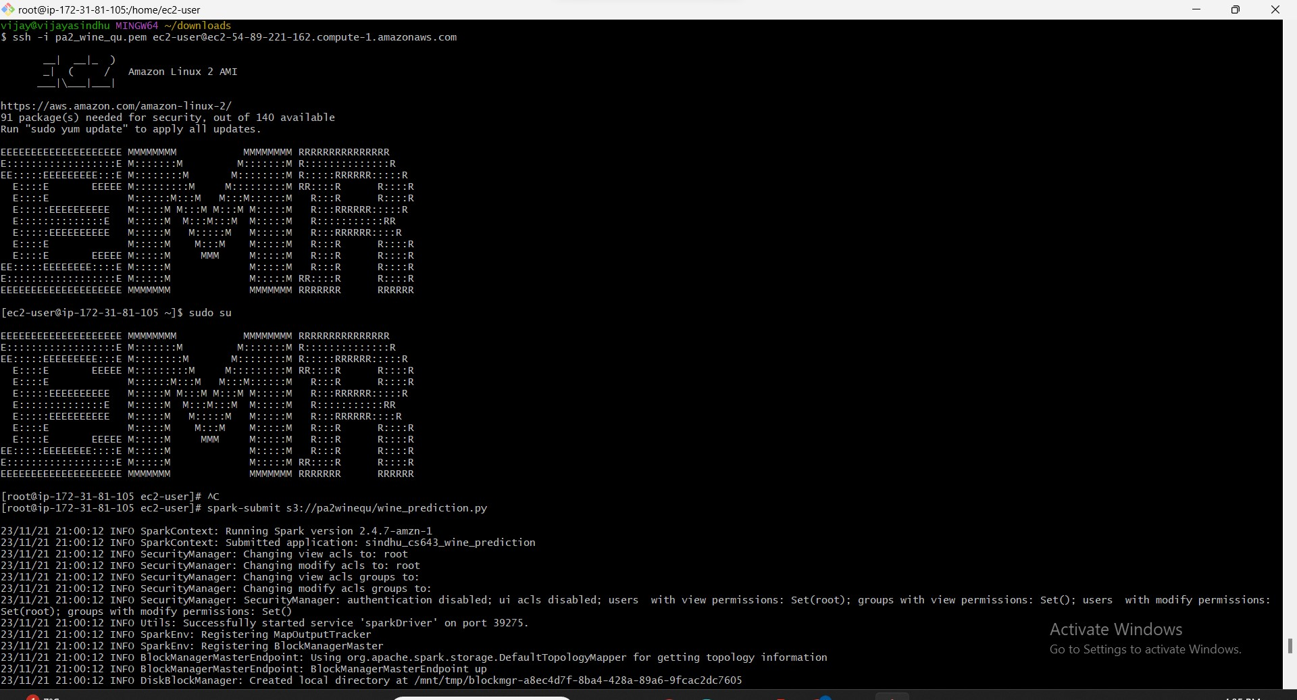

3. Use the following command to submit the job:

spark-submit s3://pa2winequ/wine_prediction.py

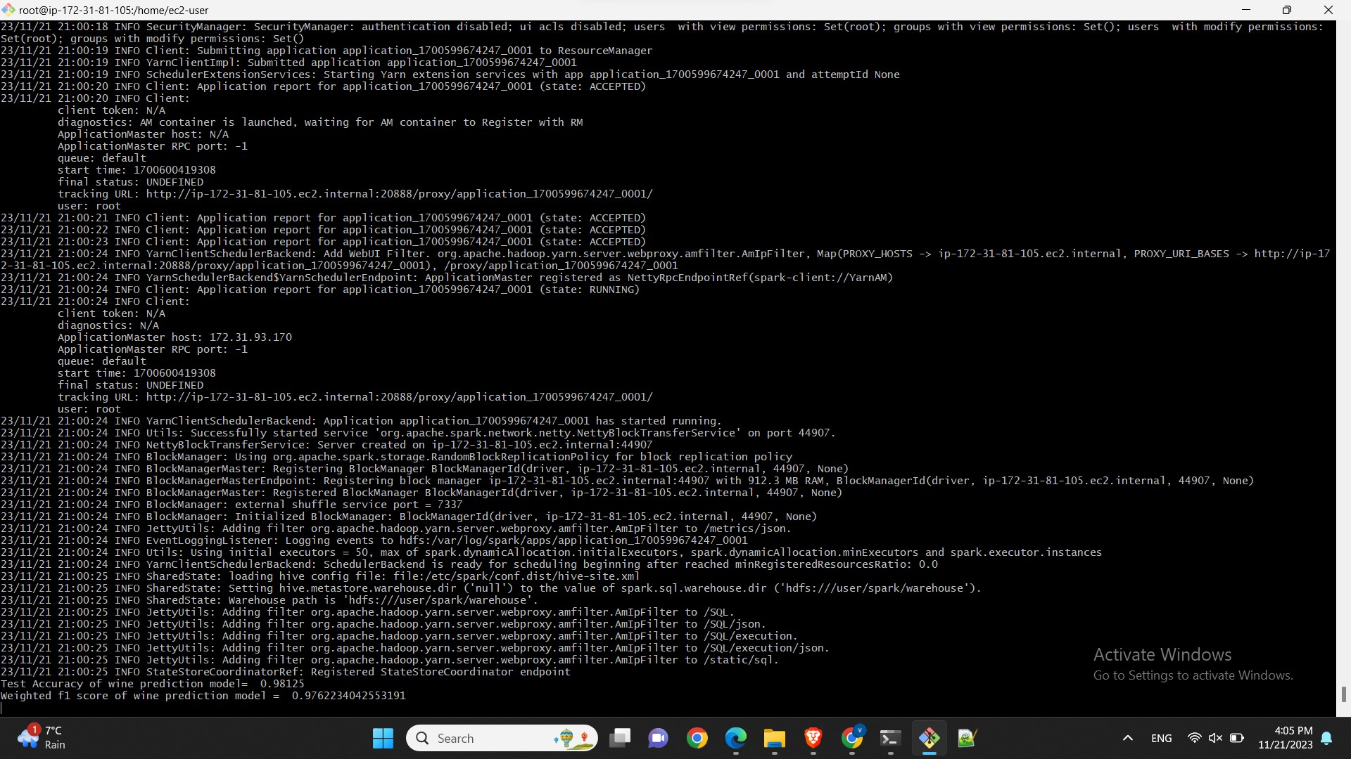

4. You can trace status of this job in EMR UI application logs. Once status is succeded a test.model will be created in s3 bucket-s3://pa2winequ.

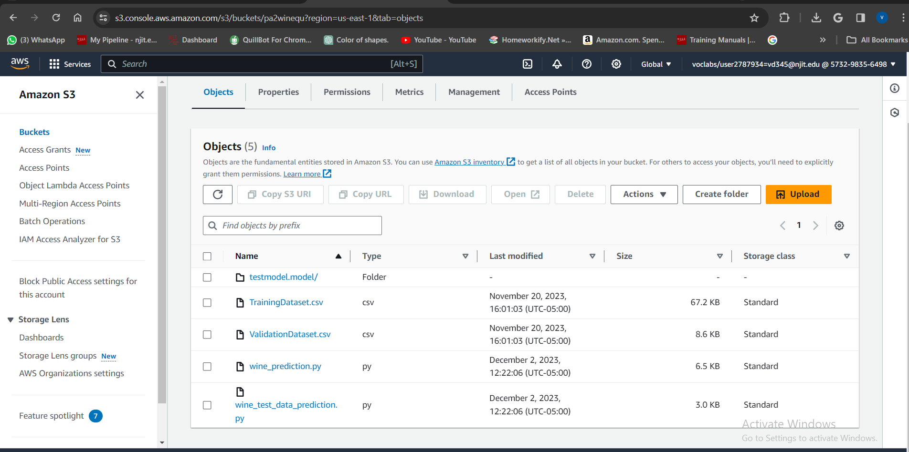

### 3. Run ML model using Docker

1. Install docker
2. Build the image of the docker file using cmd –

docker build -t wine_prediction_app .

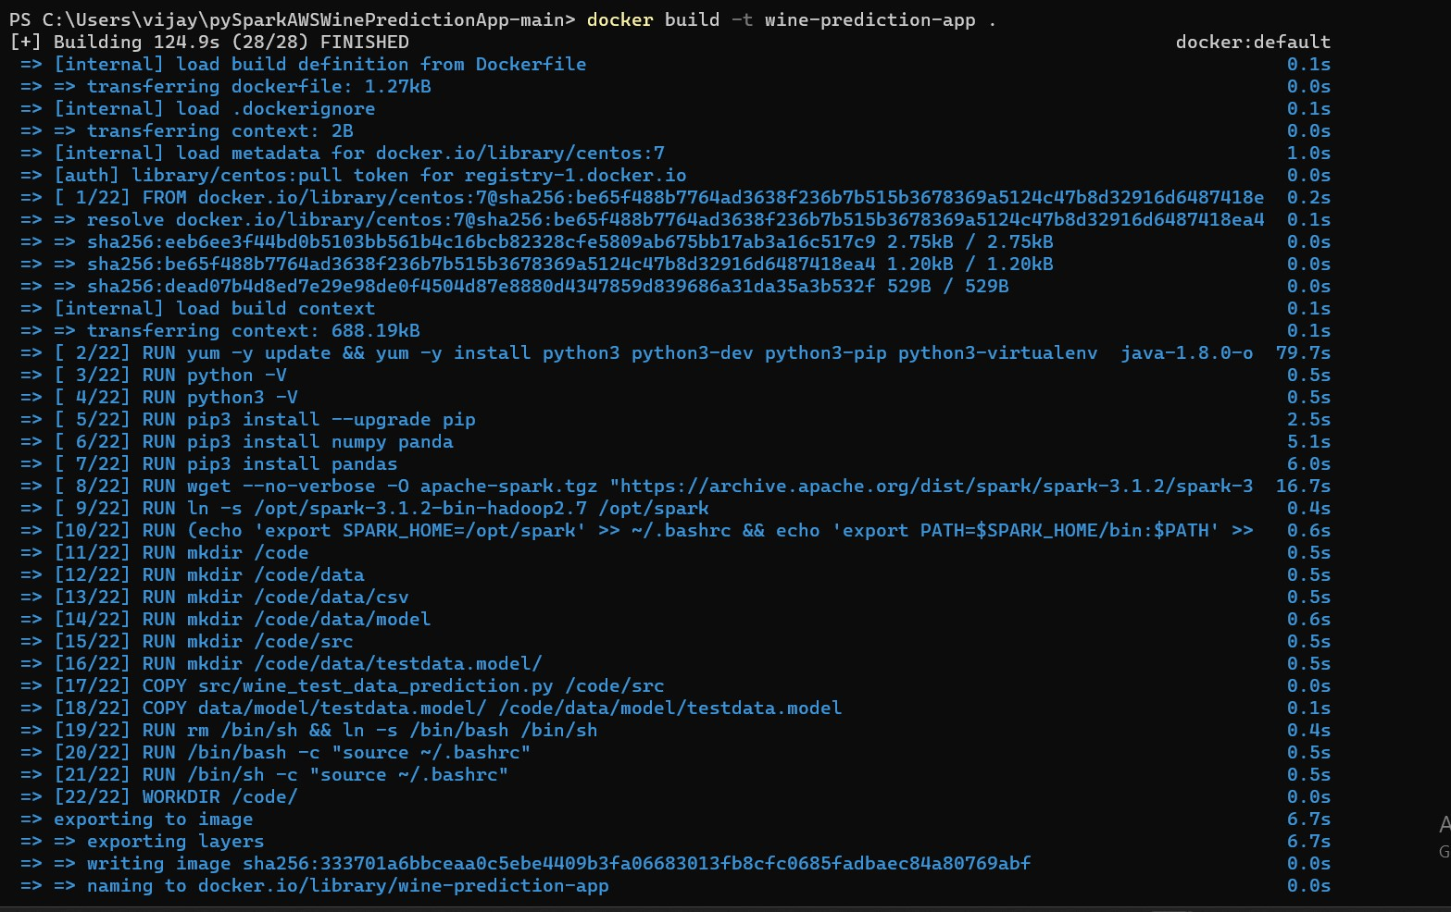

1. You can see the image using cmd

docker image ls

1. You can push this in docker hub repository

docker push vijaya340/wine_prediction_app

1. A public image has been created and posted on Docker Hub. Use the command

**Docker pull vijaya340/wine_prediction_app**

to get the image on your machine.

3. Place your training dataset file in a folder (lets call it directory dirA) , which you will Count with docker container and run it using below cmd

[docker run -v C:/users/vijay/Desktop/pa2:/code/data/csv wine-prediction-app TrainingDataset.csv](docker%20run%20-v%20C:/users/vijay/Desktop/pa2:/code/data/csv%20wine-prediction-app%20TrainingDataset.csv)

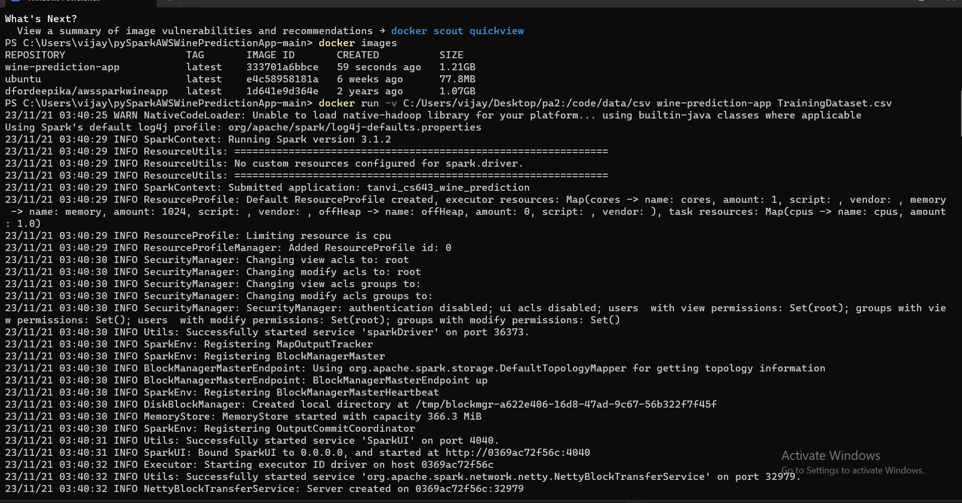

* **In summary, the wine quality was predicted with approximately 98.358 accuracy, as depicted in the image below.**

